Holding a weight

Kevin has picked up a heavy weight.
His friends are talking about the forces he needs to hold it steady.

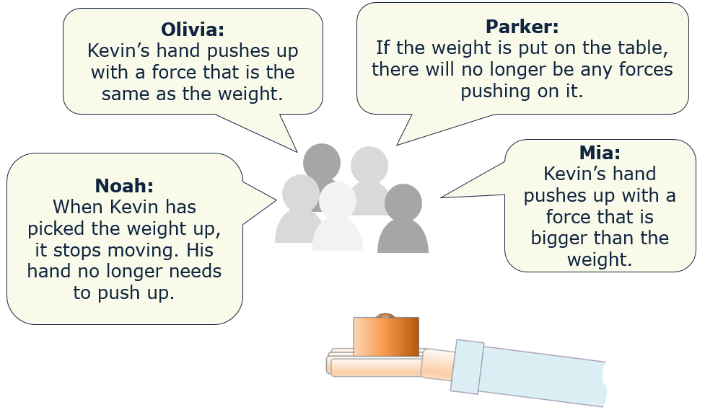

- Who is right about the forces Kevin uses to keep the weight steady?
Explain your answer.
- What mistakes do you think the other three students made?
What would you say to them to help them to understand?

Physics > Big idea PFM: Forces and motion > Topic PFM1: Forces > Key concept PFM1.2: Describing forces
Response activity
Holding a weight

Overview
Learning focus: | Forces arise when two objects interact; the force on one object is always equal in size, and opposite in direction to the force on the other object; force arrows indicate the size, direction and location of each force.
Observable learning outcome: | - Label force arrows to describe the action of the force: ‘force exerted on [object A] by [object B]’.  - Describe how forces always arise in pairs and how the force exerted by object A on object B is equal in size and opposite in direction to the force exerted by object B on object A.
Activity type: | Response, talking heads
Key words: | Force, weight, Newton, force-arrow

B | BRIDGING  This diagnostic question probes understanding of ideas that are usually taught at age 14-16, to build a bridge to later stages of learning.

This activity can help develop students’ understanding by addressing the sticking-points revealed by the following diagnostic questions:
- Diagnostic question: Describing the force?
- Diagnostic question: Describing a pair of forces?
What does the research say?
Driver et al (1994) stress the importance of paying attention to Newton’s third law in a teaching sequence. They suggest it helps students to appreciate that a force is not a property of an object but forces are characteristic of actions between objects.
Research by Terry et al (1985) has shown that expressing it in the form: “for every action (force) there is an equal and opposite reaction” is confusing for students aged 11-16. It is far clearer to describe in full: the force of object A on object B is equal in size, and opposite in direction to the force of object B pushing on object A.
A key problem for students’ understanding of Newton’s third law is the difficulty in recognising a force of reaction. Minstrell (1982) suggests giving students bridges between prior ideas and science ideas. In this instance the discussion of the forces involved in holding a weights is an effective way helping students understand the idea that forces always arise in pairs, each of equal size and with opposite direction. Later in their studies students will need to build on this idea to understand the ‘invisible’ reaction force that, for example, holds a weight on a table top. This concept is touched upon in this activity.

Ways to use this activity
Students should complete this activity in pairs or small groups, and the focus should be on the discussions. The statements are also provided as cut-out cards for students to physically organise.
Students should work together to follow the instructions on either the worksheet or the PowerPoint. Giving each group one worksheet to complete between them is helpful for encouraging discussion, but each member should be able to report back to the class. Listening in to the conversations of each group will often give you insights into how your students are thinking.
If there is disagreement when you take feedback, a good way to progress might be through structured class discussion. Ask one student to explain why they gave the answer they did; ask another student to explain why they agree with them; ask another to explain why they disagree, and so on. This sort of discussion gives students the opportunity to explore their thinking and for you to really understand their learning needs.
Differentiation
The quality of the discussions can be improved with a careful selection of groups; or by allocating specific roles to students in the each group. For example, you may choose to select a student with strong prior knowledge as a scribe, and forbid them from contributing any of their own answers. They may question the others and only write down what they have been told. This strategy encourages contributions from more members of each group.
Expected answers
Olivia is correct that Kevin’s hand will always need to push up with the same sized force, in the opposite direction, as the weight.
Mia thinks the weight will be held up unless it pushes down harder than the upwards force of Kevin’s hand. If his push was harder than the weight, he would throw it into the air.
Noah is thinking that because nothing is changing there is no force, but if there was no force from Kevin’s hand, the forces would be unbalanced and accelerate the weight downwards. The force from Kevin’s hand balances the weight so there is ‘no force left over’.
Parker thinks the same as Noah – but in this case the desk has been squashed a bit (so little you cannot see) and is pushing up like a spring.
Acknowledgments
Developed by Peter Fairhurst (UYSEG).
Images: UYSEG
References
Driver, R., Squires, A., Rushworth, P. and Wood-Robinson, V. (1994) Making sense of secondary science, research into children’s ideas, Routledge, London, England.
Minstrell, J. (1982) ‘Explaining the “at rest” condition of an object’, The Physics Teacher 20:10-14.
Terry, C., Jones, G. and Hurford, W. (1985) ‘Children’s conceptual understanding for force and equilibrium’, Physics Education 20(4): 162-5.

